Folksworth & Washingley
Parish Council

N O T I C E O F M E E T I N G

A MEETING of the Parish Council will be held on Tuesday April 16th ,2024 at 7.20pm in the Village Hall, Manor Road, Folksworth.

All members of the Council are hereby summoned to attend for the purpose of considering and resolving upon business to be transacted as set out below.

Members of the public and press are invited to follow the meeting and to address the council at its Open Forum.
AGENDA
Open Forum

2024/3071 Apologies for Absence

2024/3072 Declarations of Interest/Dispensations for Agenda items
(Section 27 Localism Act 2011)

2024/3073 Approval of Full Council Meeting Minutes dated March 19, 2024

2024/3074 Matters Arising from the Minutes for items not on current Agenda (for information only)

2024/3075 Finance

3075.1 To approve the Accounts
3075.2 To approve the Balance Sheet

2024/3076 To Minute the following payments
Additional payments may be tabled.

201173 RJC Countryside Grass Cutting £576.00
201174 Mrs J Stanbridge Salary £486.40
201175 Mrs J Stanbridge Travel £15.60
201170 RJC Countryside Village Maintenance £216.00
201171 Paul Tillson Pavilion Repairs £1620.00

1 Speedwatch and any update bid for speed signs
2 Community Orchard including need for bin. Any update re permission to reduce height of trees
3 Village grass cutting and No mow May
4 Litter picking. ? Re inform residents of available equipment.
5 Playing field to acknowledge repaired equipment, update on repairing piece of exercise equipment, table tennis table is no longer straight. Can this be repaired.
6 Footpaths. Any response from Footpaths officer. Possibility of applying grant to improve footpath from Manor Rd and possibly more bulbs for village in Autumn.
7 Green bins. Reaction so far to new service by HDC.

2024/3064 Annual Parish Meeting – May 14th, 2024

2024/3065 No Mow May

2024/3066 The Fox Public House

2024/3067 Parish Maintenance Walk

2024/3068 Parish Information & Councillor Reports

2024/3069 Any Urgent Business
In accordance with section 100(B)(4) of the Local Government Act 1972 (as amended) the Chair will admit an item of urgent business in order that it can be dealt with at the earliest opportunity provided it has been raised at least 24 hours before the meeting.

2024/3070 Closure of meeting and next scheduled meeting date confirmed as April 16,2024 at 7.20pm in the Village Hall, Manor Road, Folksworth.

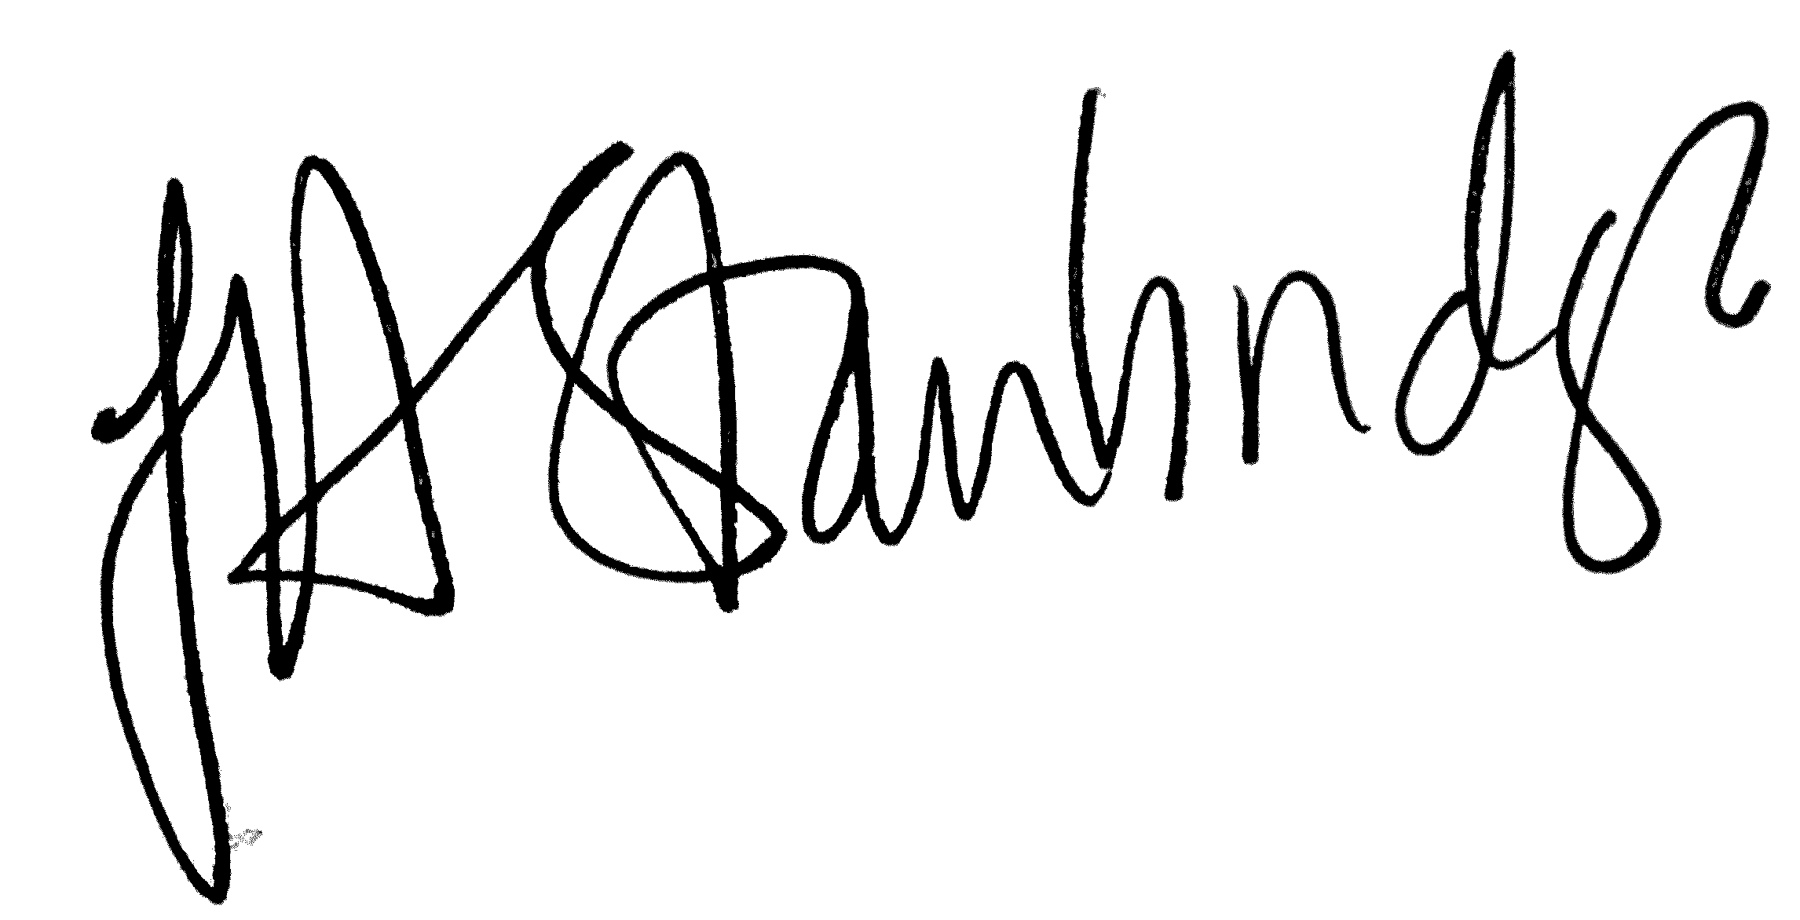
Jackie Stanbridge
Clerk to the Council/Responsible Financial Officer
April 11, 2024

