Folksworth & Washingley
Parish Council

N O T I C E O F A N N U A L G E N E R A L M E E T I N G

THE ANNUAL GENERAL MEETING of the Parish Council will be held on Tuesday May 21st ,2024 at 7.20pm in the Village Hall, Manor Road, Folksworth.

All members of the Council are hereby summoned to attend for the purpose of considering and resolving upon business to be transacted as set out below.

Members of the public and press are invited to follow the meeting and to address the council at its Open Forum.
AGENDA
Open Forum

2024/3090 Election of Chair

2024/3091 Election of Vice-Chair

2024/3092 Appointment of other officers
Capalc/Cambs Acre
Grass Cutting
Social Media
Speedwatch
Transport & police liaison.
Tree Warden
Village Hall
Village Maintenance Walks
Washingley

2024/3093 Apologies for Absence

2024/3094 Declarations of Interest/Dispensations for Agenda items
(Section 27 Localism Act 2011)

2024/3095 Approval of Full Council Meeting Minutes dated March 19 & April 16, 2024

2024/3096 Matters Arising from the Minutes for items not on current Agenda (for information only)

2024/3097 Finance
3094.1 To approve the Accounts.
3094.2 To approve the Balance Sheet.
3094.3 To receive the report from the Internal Auditor
2024/3098 To Minute the following payments.
Additional payments may be tabled.

201177 Rospa Playsafety Annual Inspection £151.20
201178 RJC Countryside Grass Cutting £486.00
201179 Mrs J Stanbridge Salary £486.40
201180 Mrs J Stanbridge Travel £15.60
201181 Cambridgeshire Acre Annual Membership £65.00

2024/3099 Annual Parish Meeting – May 14th, 2024 - Review

2024/3100 Parish Information & Councillor Reports

2024/3101 Any Urgent Business
In accordance with section 100(B)(4) of the Local Government Act 1972 (as amended) the Chair will admit an item of urgent business in order that it can be dealt with at the earliest opportunity provided it has been raised at least 24 hours before the meeting.

2024/3102 Closure of meeting and next scheduled meeting date confirmed as June 18 at 7.20pm in the Village Hall, Manor Road, Folksworth.

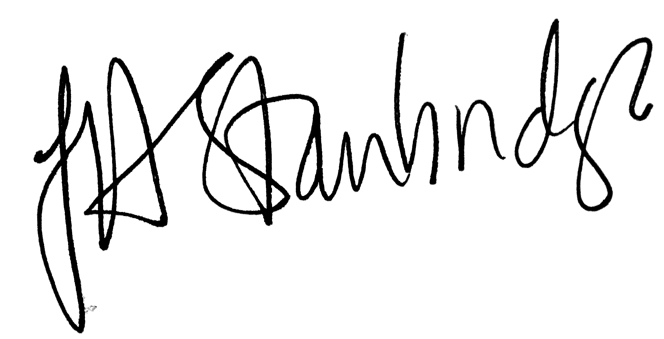
Jackie Stanbridge
Clerk to the Council/Responsible Financial Officer
May 16, 2024

